# BUS RESERVATION SYSTEM

**A MINIPROJECT REPORT**

***Submitted by***

# M.GAYATHRI (Reg No: 1712022)

**BACHELOR OF ENGINEERING**

**In**

**COMPUTER SCIENCE AND ENGINEERING NATIONAL ENGINEERING COLLEGE**

**(An Autonomous Institution, Affiliated to Anna University Chennai) K.R.NAGAR, KOVILPATTI: 628 503**

# ABSTRACT:

Traveling is a large growing business across all countries. Bus reservation system deals with maintenance of records of details of each passenger. It also includes maintenance of information like schedule and details of each bus.

We observed the working of the Bus reservation system and after going through it, we get to know that there are many operations, which they have to do manually. It takes a lot of time and causing many errors while data entry. Due to this, sometimes a lot of problems occur and they were facing many disputes with customers. To solve the above problem, and further maintaining records of passenger details, seat availability, price per seat, bill generation and other things, we are offering this proposal of computerized reservation system.

By using this software, we can reserve tickets from any part of the world, through telephone lines, via internet. Customer can check availability of bus and reserve selective seats. The project provides and checks all sorts of constraints so that user does give only useful data and thus validation is done in an effective way.

# TOOLS USED:

* HTML
* CSS
* JAVA

# TECHNOLOGY USED:

* Netbeans
* MS Access

# FRONT END:

* HTML

# BACK END:

* MS Access

# MODULES:

* Index.html – main page of bus reservation system(home page)
* Book.html- the details of the passenger and the type of bus is selected in this page
* Insert.java- servlet page

# CODE:

**Insert.java**

/*

* To change this license header, choose License Headers in Project Properties.
* To change this template file, choose Tools | Templates
* and open the template in the editor.

*/

import java.io.IOException; import java.io.PrintWriter;

import static java.lang.System.out; import java.sql.Connection; import java.sql.DriverManager; import java.sql.ResultSet;

import java.sql.SQLException;

import javax.servlet.ServletException; import javax.servlet.annotation.WebServlet; import javax.servlet.http.HttpServlet;

import javax.servlet.http.HttpServletRequest; import javax.servlet.http.HttpServletResponse;

/**

*

* @author Gayu

*/

@WebServlet(urlPatterns = {"/insert"}) public class insert extends HttpServlet {

/**

* + Processes requests for both HTTP <code>GET</code> and

<code>POST</code>

* + methods.

*

* + @param request servlet request
  + @param response servlet response
  + @throws ServletException if a servlet-specific error occurs
  + @throws IOException if an I/O error occurs

*/

protected void processRequest(HttpServletRequest request, HttpServletResponse response)

throws ServletException, IOException { response.setContentType("text/html;charset=UTF-8"); try (PrintWriter out = response.getWriter()) {

/* TODO output your page here. You may use following sample code. */

String no_of_seats=request.getParameter("s1");

String name_of_passenger=request.getParameter("t1"); String gender=request.getParameter("gender");

String mobileno=request.getParameter("m1"); String bustype=request.getParameter("bus");

out.println("<!DOCTYPE html>"); out.println("<html>"); out.println("<head>"); out.println("<title>Servlet insert</title>"); out.println("</head>"); out.println("<body>");

try{

Class.forName("sun.jdbc.odbc.JdbcOdbcDriver") ;

Connection con=DriverManager.getConnection("jdbc:odbc:reserve","","");

java.sql.Statement stmt=con.createStatement();

String query="insert into reserve values(' "+name_of_passenger+" ',' "+gender+" ',' "+mobileno+" ',' "+bustype+" ',' "+no_of_seats+" ')";

String q1="select * from reserve";

out.println("\"<table border=\"5\">\n" + "<tr>\n" +

"<th>name_of_passenger</th>\n" + "<th>gender</th>\n" + "<th>mobileno</th>\n" + "<th>bustype</th>\n" + "<th>no_of_seats</th>\n" + "</tr>\n" +

"<tr>\n"+

"<td>"+name_of_passenger+"</td>\n"+

"<td>' "+gender+" '</td>\n"+ "<td>' "+mobileno+" '</td>\n"+ "<td>' "+bustype+" '</td>\n"+ "<td>' "+no_of_seats+" '</td>\n"+ "</tr>\n"+

"</table>\"");

int iupdate=stmt.executeUpdate(query); if(iupdate>0 )

{

out.println("Your tickets have been booked!!"); out.println("<br>");

out.println("<a href='index.html'> Click here to book another tickets

</a>");

}

else {

out.println("data inserted unsuccessfully");

}

ResultSet iu=stmt.executeQuery(q1); out.println("\"<table border=\"5\">\n" +

"<tr>\n" +

"<th>name_of_passenger</th>\n" + "<th>gender</th>\n" + "<th>mobileno</th>\n" + "<th>bustype</th>\n" + "<th>no_of_seats</th>\n" + "</tr>\"");

while(iu.next())

{

out.println("\"<tr>\n"+ "<td>"+iu.getString(1)+"</td>\n"+ "<td>"+iu.getString(2)+"</td>\n"+ "<td>"+iu.getString(3)+"</td>\n"+ "<td>"+iu.getString(4)+"</td>\n"+ "<td>"+iu.getString(5)+"</td>\n"+ "</tr>\"");

}

out.println("\"</table>\"");

}

catch(ClassNotFoundException | SQLException e)

{

out.println("data inserted unsuccessfully"); } out.println("</body>"); out.println("</html>");

}

out.println("<h1>Servlet insert at " + request.getContextPath() + "</h1>");

out.println("</body>"); out.println("</html>");

}

@Override

protected void doGet(HttpServletRequest request, HttpServletResponse response)

throws ServletException, IOException { processRequest(request, response);

}

@Override

protected void doPost(HttpServletRequest request, HttpServletResponse response)

throws ServletException, IOException { processRequest(request, response);

}

@Override

public String getServletInfo() { return "Short description";

}// </editor-fold>

}

# Output:

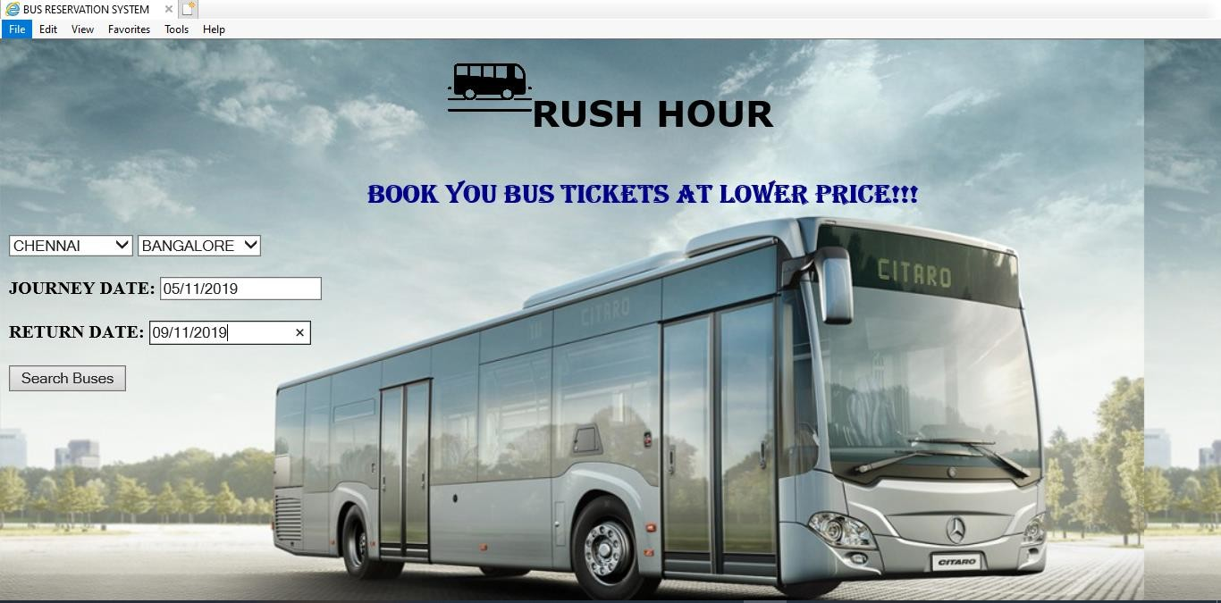**Home page**

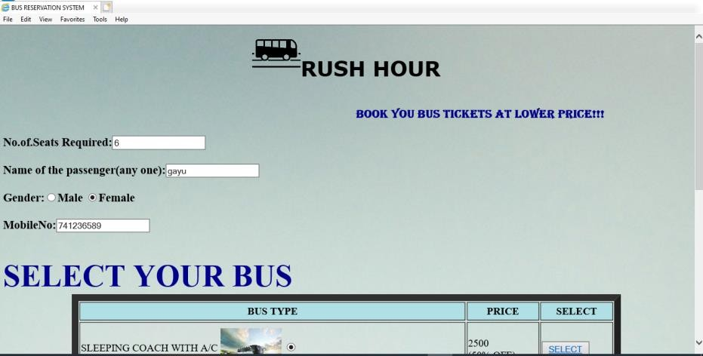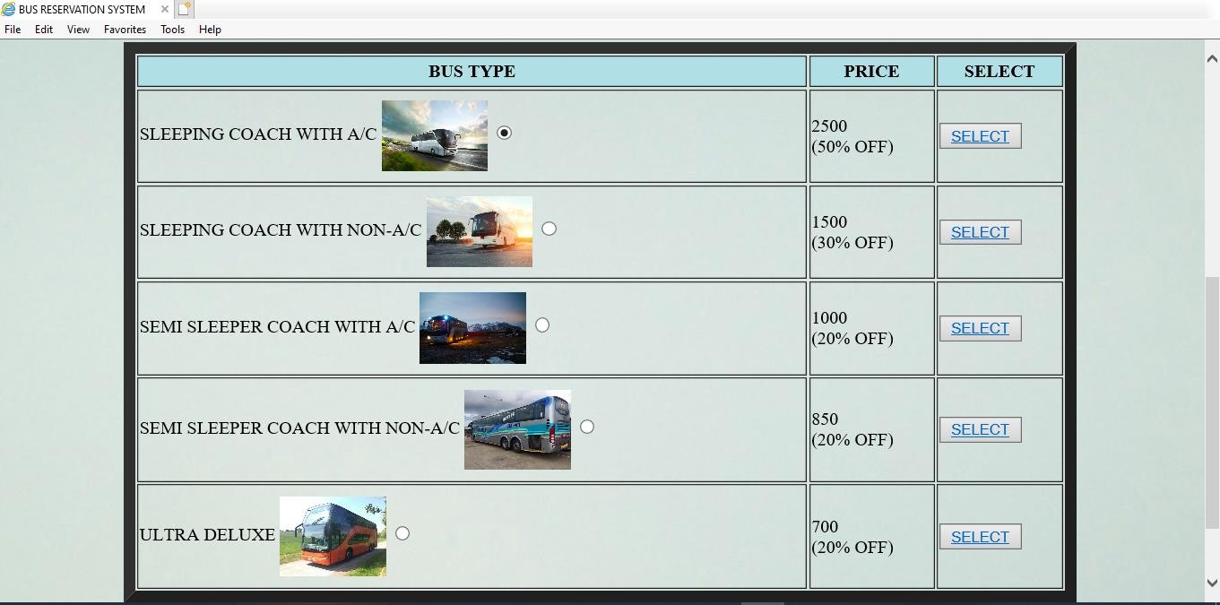

**Report:**

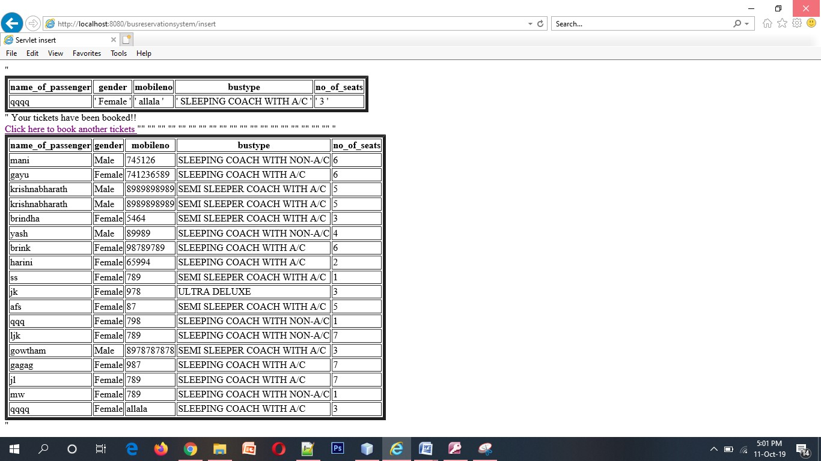

**Conclusion:**

In this fast moving life where people don't have time to reserve the tickets manually, online bus reservation system has emerged as a time saving and convenient way of reserving tickets for bus. Thus, Online Bus ticket reservation System has become a boon for the travelers who do not stand in a long queue and book the tickets. The online bus ticket reservation system provides various features to the travelers to book the tickets efficiently and enjoy the convenience of booking tickets online event by sitting at their homes/offices. This results in a comfort for travelers as there is no more annoying way of standing in a queue and booking the tickets.